Togo Land Management System
Requirements Definition Document

Created by: Suntory Tech Group

Version 1.0

Revision History

Rev # | Revised By | Description | Date
1.0 | Pineda, Juan Cesar Damaso  Loganimio, Samuel Lucas | Created the initial version | 24/Jan/19
2.0 | Pineda, Juan Cesar Damaso |  | 05/Feb/19

Background

Togo's Ministry of Land Distribution is planning to digitalize the country's land management. Based on this vision, they are planning to introduce a land management system.

Purpose

Modernize the Togo’s land distribution process in order to increase land accessible allowing the citizens to acquire secure land legally, and avoiding land conflict.

Functional Requirements
  - Log-in Management
    - Users should be able to log-in to the system via username and password
    - Users should be able to log-in from different browsers simultaneously (multiple log-in)
  - User Management
    - Users should have their own user profile in the system
    - The user profile should include the following details:
      - User Type
      - First Name
      - Last Name
      - Designation
      - Password
  - Land Records Management
    - The user should be able to create a new land record
      - The user should be able to input the following land details
        - Location
          - Address
          - Coordinates
        - Land Owner
        - Land Status
          - Owned
          - For-sale
          - Restricted
        - Land Description
        - Boundary details
        - Record of Rights
        - Right of Way Details
        - Land Value (Cost)
      - The user should be able to upload the following documents
        - Title Deed
        - Certificate of Title
        - Certificate of Lease
        - Certificate of Sale
        - Record of Rights
    - The user should be able to update land record details
    - The user should be able to search land record details
  - Land Transaction Management
    - The user should be able to approve or disapprove land sales
    - The user should be able to approve or disapprove land transfers
  - Map Visualization Management
    - The user should be able to view the land through an interactive map
      - The user should be able to view the satellite and terrain image of the map
      - The user should be able to view the different lands that were created in the system
  - Administration Management
    - User Administration
      - There should be a facility to create and update user profiles
    - Data Administration
      - There should be a facility to set data backup schedules
      - The system should be able to save data on a cloud server
      - The system should be able to keep of record of data for three years
    - Security Administration
      - There should be a facility to set access permissions depending on the user type
      - Full security of cameras
      - There should be a facility to reset access permissions

Access Permission
        - Limited Access Permission
        - Blocked Permission

Non Functional Requirements
  - Map creation
    - The system should be able to plot all land that was created in the system (based on address, coordinates, boundary)
  - Usability
    - Searching must be simple to perform with only three actions at minimum to produce meaningful results

  - Scalability
    - The System must adapt to the growing user base
    - The system should be capable of handling multiple request from search queries
  - Security
    - Digital evidence of the exchange/acquisition may not be tampered with to avoid fraud
    - advanced encryption system (AES) will be applied to protect user privacy .
    - As well as end to end encryption for user credentials evaluation to access the system .
    - Only administrator, and the operator of the system are permitted to modify inputs in the system's terminal by password.
  - Backup
    - The system should be able to run in multiple operating systems

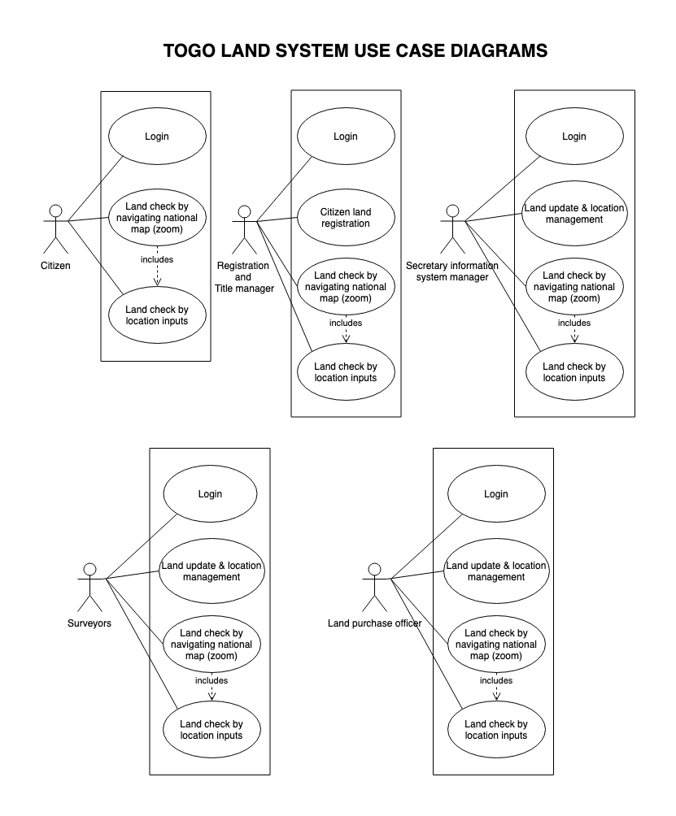

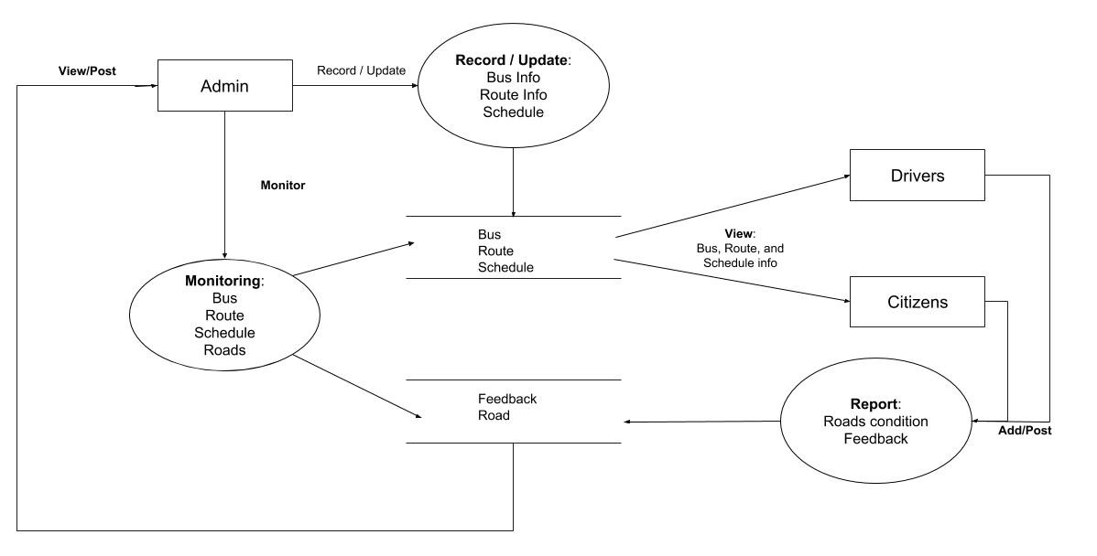

Sample Bus Route App DFD

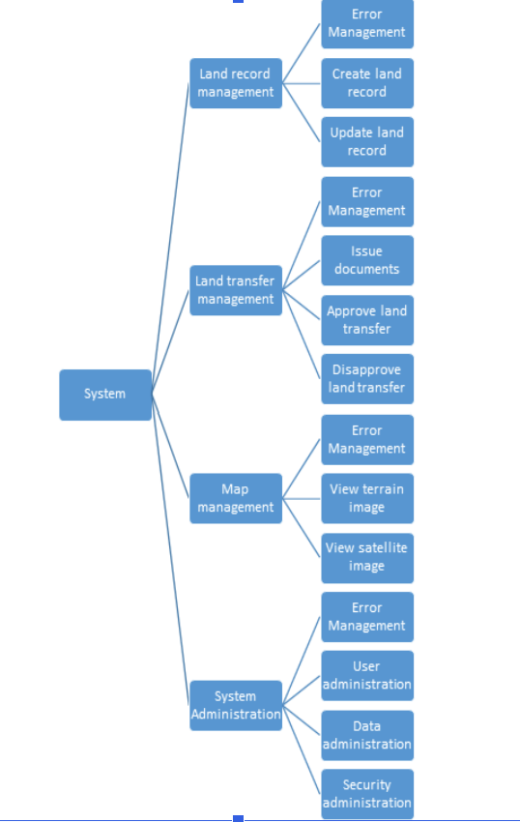
Functional Block Diagram

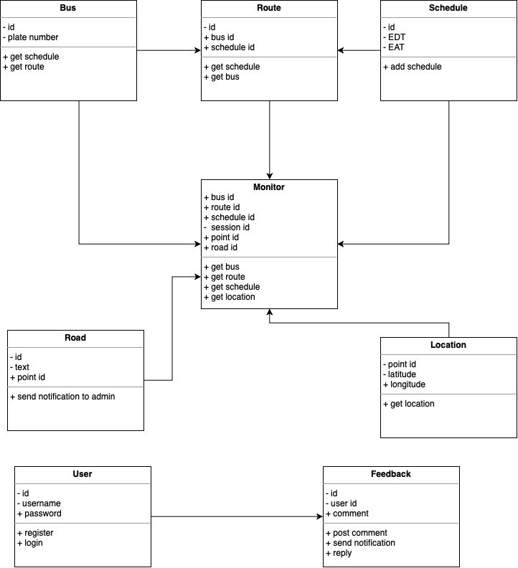

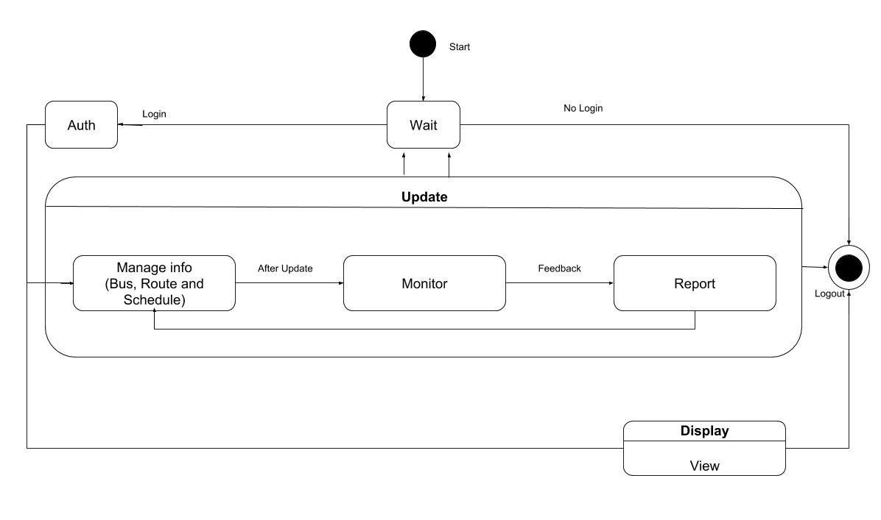
Sample Bus Route App State Machine Diagram.

